



**Bienvenido(a) a la Red de los mejores profesionales del Ecuador**

Te ayudaremos a que tu negocio crezca

¡Comencemos!

Te vas a registrar como:







¡Desde ahora serás parte de la nueva era!

Ingresa la mayor cantidad de información posible para que los clientes te conozcan mejor, está será organizada y visualizada como tu **perfil profesional**, es la hora de mostrar todo tu potencial, cuando desees podrás editar o agregar más información, fotos, videos, etc. desde "Mi Cuenta".

Campos obligatiorios*

* Inserta una foto o logo de la empresa



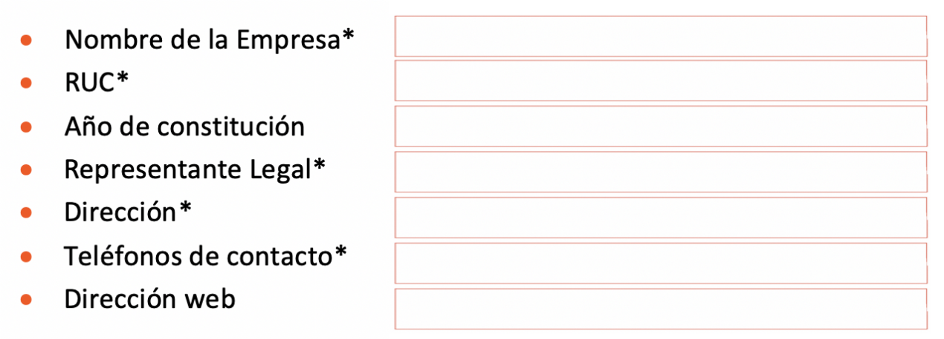

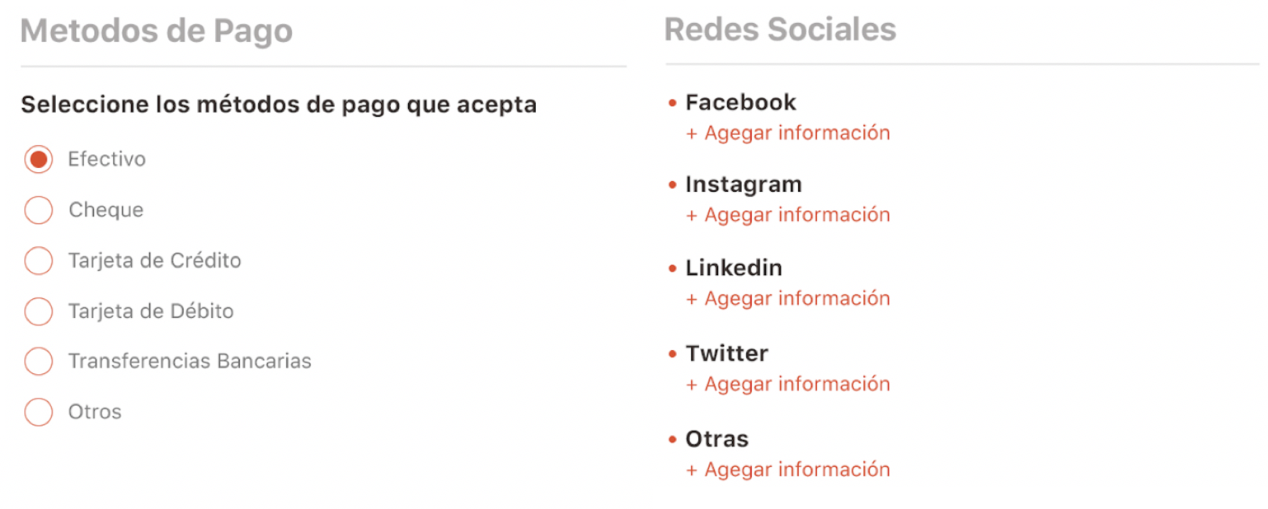

Note: Ag**r**egar is mispelled a "r" is missing please change all



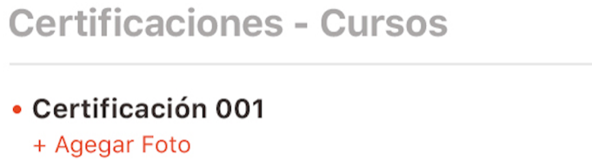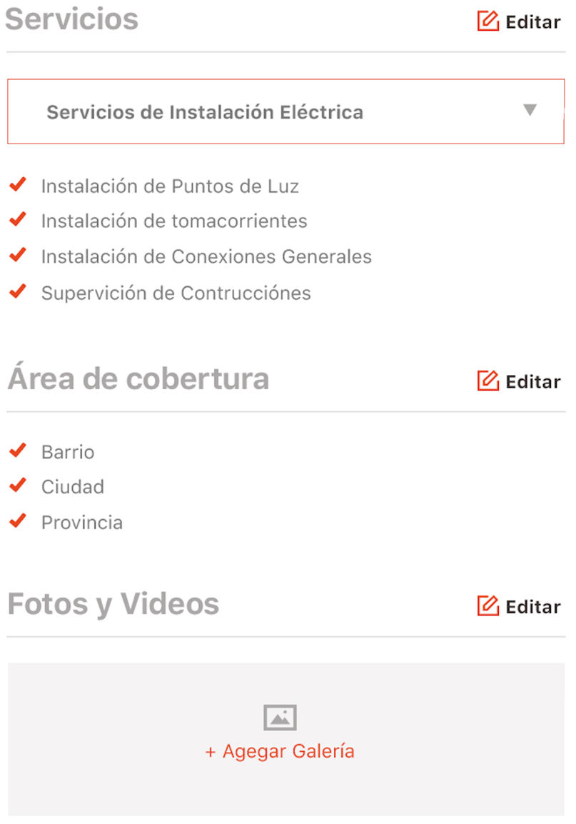

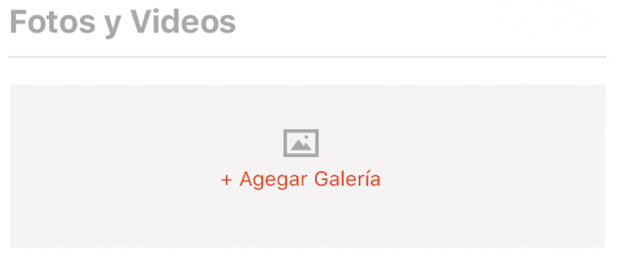





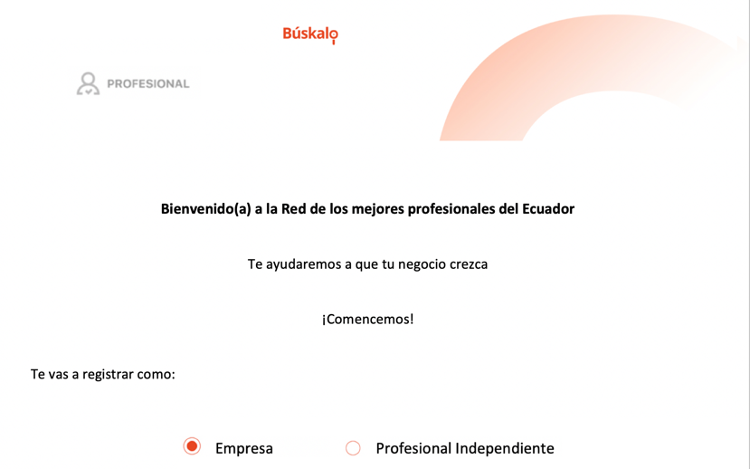The flow will be as follow:

The website will be available for registration only the first 2 months, so when the professionals go to

www.buskalo.com this will be the first screen to be shown (not the Homepage)

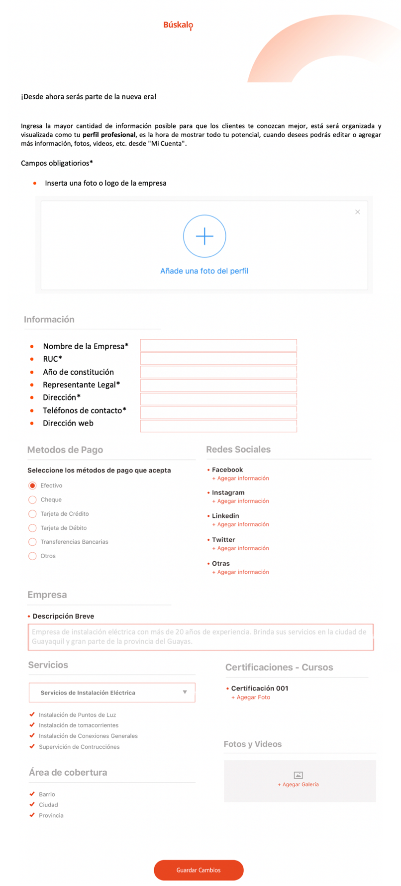



When the pro choose if he is a Company or

Independent professional, the ***registration***

***form*** will appear (this example is for a Company)

this screen will appear the first time only, please

notice that we don't need a menu on the side,

footer or header.

Once this form is been filled it will go to "Mi perfil" and the professional will have access to the PRO web.

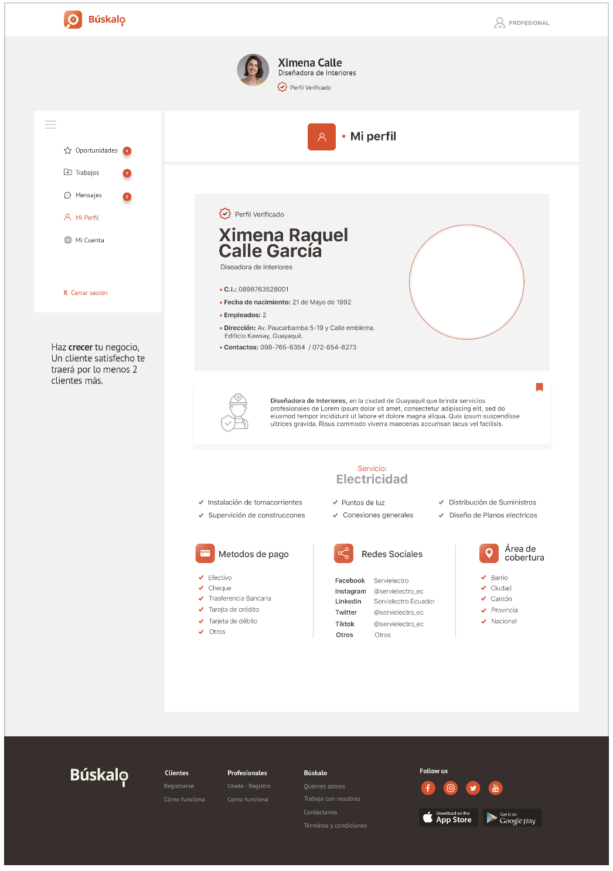

Although they won't be able to use the first 3 options (Oportunidades, Trabajos & Chat) until the user web is available they will get to know and explore how the platform works.

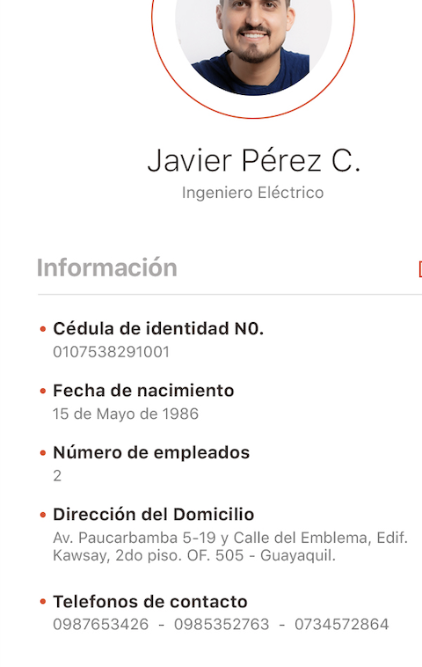The above example is for a Company registration, for a Independent professional we need to change to this:

Add:

Profesión

Which it will fill the space where "Ingeniero Electrico" is

now

This also applies for this only (not for Companies)

Please correct Ag**r**egar where is applicable.